Use puzzle generator to create challenge
http://www.mensus.net/brain/logic.shtml
http://www.phrebh.com/logicgrid.html
http://www.mensus.net/brain/logic.shtml

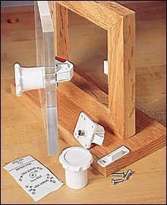

Hidden magnetic lock — $20
A strong magnet is hidden in a chess piece. This will be used to open a box.

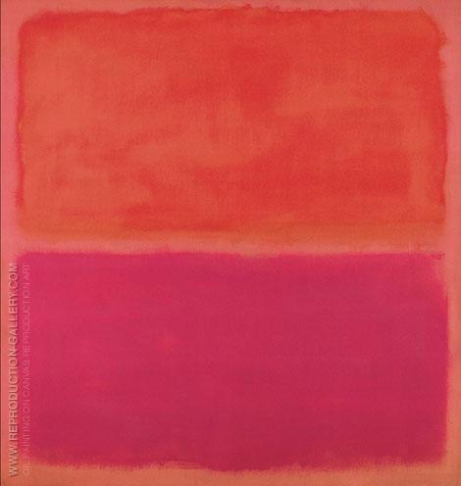
Oil reproduction as gift

Monstersandgods.com

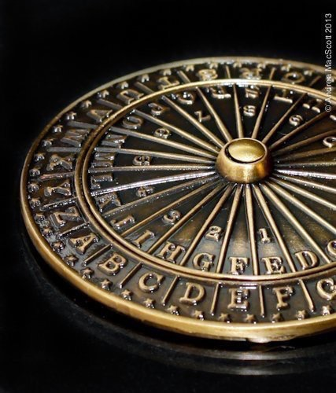
Decoder wheel — $20

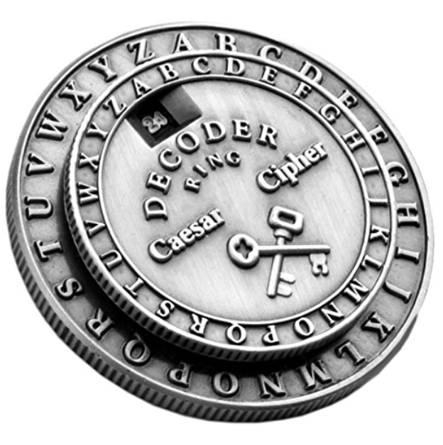
Classic Caesar Cipher Medallion Silver Decoder Ring — $20

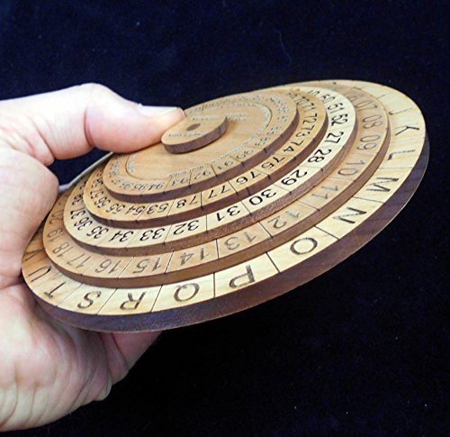
Cipher Disks — $35

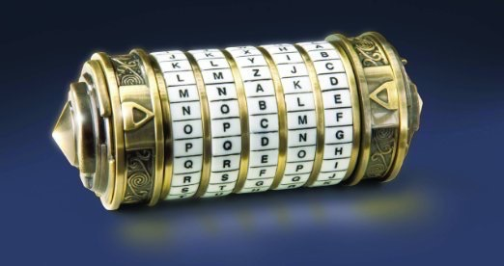
Cyrptix with 2.9” compartment — $40

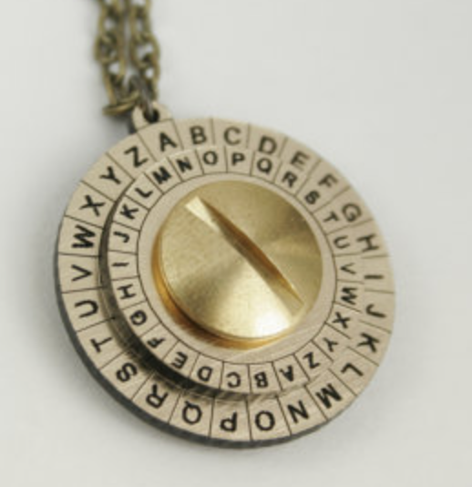
Cipher wheel — $25

Hidden Camera Motion Detector Video Recorder — $25
could be brought to the party in a prop and record the unfolding

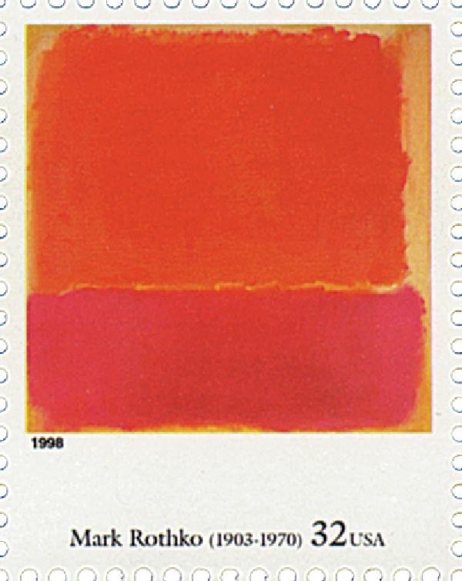
Stamps — $3 each

Notecards — $20

Creative space rooms shop
https://m.youtube.com/watch?v=bQbbtnTz1KE

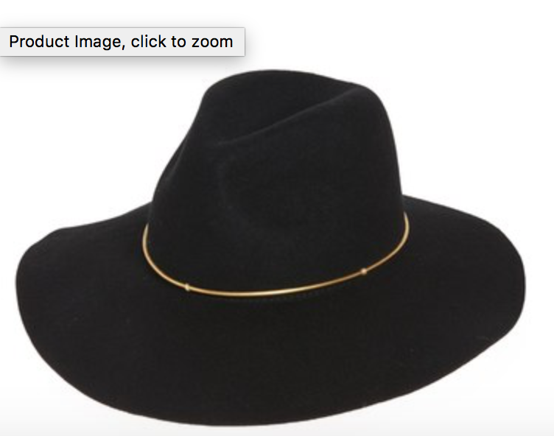
Women’s fedora
http://shop.nordstrom.com/s/hinge-wool-panama-hat/4353243?origin=category-personalizedsort&fashioncolor=BLACK

Retractable cable lock through metal pipe to hold artwork at Ruta Del Vino

Map

